Group members names: ________________________________________ period______ kitchen#_____

__________________________________________________________________________________________________________________________________________________________________________

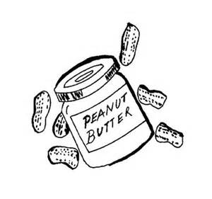PEANUT BUTTER COOKIES

INGREDIENTS:

½ cup softened butter 1 ½ cups flour

½ cup flour ½ teaspoon baking soda

½ cup sugar ½ teaspoon baking powder

½ cup brown sugar

1 egg

___ALL____1. Tie hair back & wash hands.

__________2. Fill sink with hot water and soap.

__________3. Unwrap butter and place in large bowl.

__________4. Measure ½ cup peanut butter and add to large bowl, cream together.

__________5. Measure ½ cup granulated sugar, add to bowl.

__________6. Measure ½ cup brown sugar, add to bowl & mix.

__________7. Crack 1 egg into a custard cup, and add to butter/sugar mixture.

__________8. Measure 1 ½ cups flour and add to ingredients, **DO NOT MIX.**

__________9. Measure ½ **teaspoon** baking soda & ½ **teaspoon** baking powder, add to

ingredients & stir until combined.

_________10. Gather dough into a ball and tightly wrap in plastic wrap.

_________11. Get a piece of tape or sticker and label with period, day & kitchen. Put

sticker on your dough. Give the dough to Mrs. Cislo to refrigerate.

_________12. Wash all dishes.

_________13. Dry all dishes.

_________14. Put dishes away in proper location.

_________15. Wash & dry all work surfaces.

_________16. Call teacher for kitchen inspection.

Day 2:

___ALL_____1. Tie hair back & wash hands.

___________2. Check oven to preheat oven 375 degrees.

___ALL_____3. Shape dough into 1 inch balls and place 2 inches apart on a cookie sheet.

___________4. Flatten out each dough ball by either:

a) pushing a fork across the dough in a crisscross patern

b) using a potato masher

c) pushing an unwrapped Hershey Kiss into the center

___________5. Place cookies into the oven on the center rack. Set timer for 8 minutes.

___________6. Fill sink with hot water & soap. Wash all dishes including cookie sheet &

cooling rack.

___________7. Dry dishes & put away in proper location.

___________8. When timer goes off, check cookies. If they are done take out, if not add 2

more minutes. When done, take out of the oven & place on stove top to

slightly cool (1-2 minutes).

___________7. Remove cookies from cookie sheet and place on a cooling rack to continue to

cool.

____All_____8. Divide cookies up between group members.

___________9. Clean all work surfaces, including stove top & counters.

__________10. Call for teacher inspection.